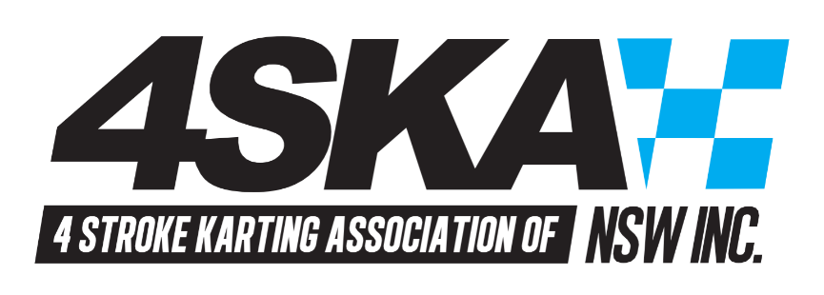
Agenda
Four Stroke Karting Association NSW Inc.
Annual General Meeting - 7:00pm – 10th August 2022
1. Chairpersons welcome
2. Declaration of pecuniary interests
3. Attendance & Apologies
4. Minutes of the preceding AGM
5. President’s report - Acceptance
6. Treasurer’s report – Acceptance
7. Financial Statements
8. Acknowledgement of the 2020/21 committee and president
9. Announcement of the nominations for committee positions
10. Election of the 2021/22 Committee
11. Welcoming of the new committee
12. Special business
13. General business
14. Close
Agenda
Four Stroke Karting Association NSW Inc.
General Meeting – 10th August 2022

